CHINO BACKSHOPS
CAN MOTOR RE-POWER KITS

KIT#10
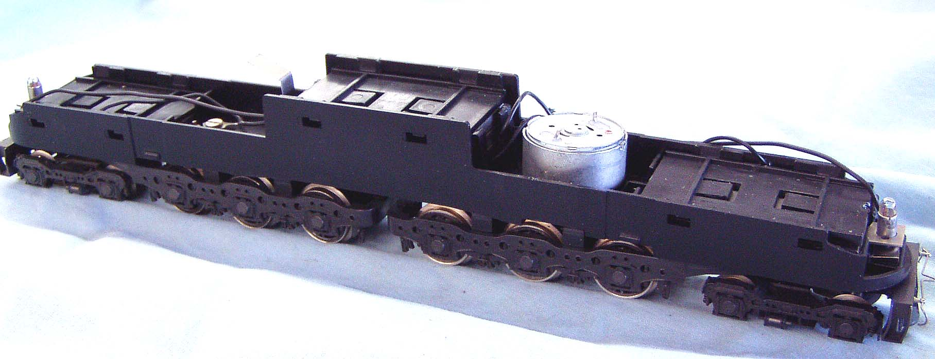
HO SCALE AHM-RIVAROSSI GG1 ELECTRIC LOCOMOTIVES
or
AHM E8 and K-M DIESELS

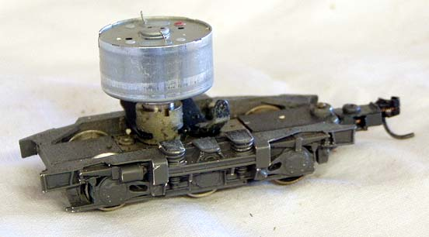

KIT INCLUDES:

1 ROUND CAN MOTOR WITH SHAFT EXTENSION and
ILLUSTRATED INSTALLATION INSTRUCTIONS

MOTOR SPECS:
12VDC 68ma 6800rpm
0.962” X 0.488” 24mm X 12mm
2mm shaft, 5mm long

THE PHOTO SHOWS THE MOTOR INSTALLED ON A
RIVAROSSI GG1 CHASSIS AND K-M POWER TRUCK
(NOT INCLUDED WITH KIT)
THIS MOTOR MOUNTS INSIDE THE RIVAROSSI MOTOR CASE
Please note: This kit is intended for the locomotive versions that have the round AHM motor.

