CHINO BACKSHOPS
CAN MOTOR RE-POWER KITS

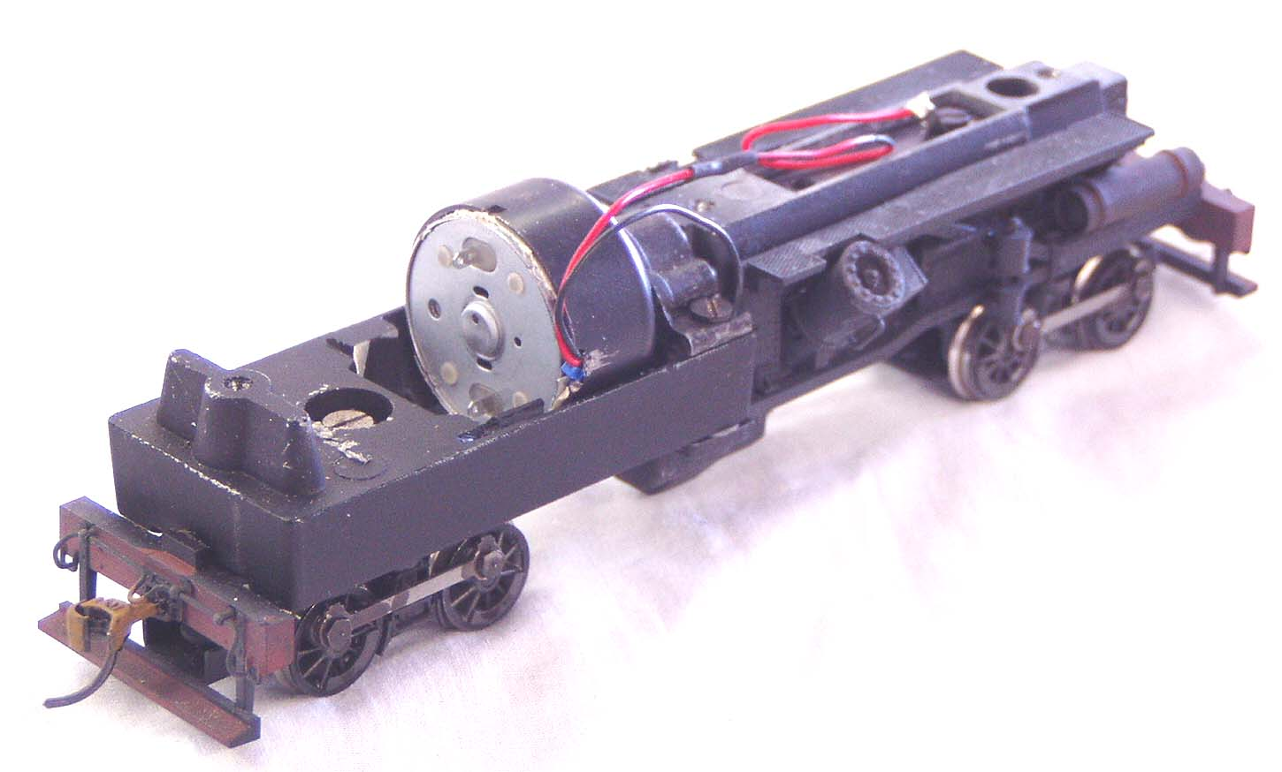
KIT#11 HO SCALE RIVAROSSI HEISLER

KIT INCLUDES:

1 ROUND CAN MOTOR, AND ILLUSTRATED INSTUCTIONS

MOTOR SPECS:
SIZE 24mm X 12mm
SHAFT 10mm X 2mm
VOLTAGE 12VDC
RPM 6800
CURRENT 68ma
STALL CURRENT 800ma

THE PHOTO SHOWS THE MOTOR INSTALLED ON
A RIVAROSSI 2 TRUCK HEISLER CHASSIS (NOT INCLUDED WITH KIT)
This motor mounts inside the Rivarossi motor case

PLEASE NOTE:
THIS KIT IS INTENDED FOR THE CIRCA 2000 HEISLER 2 OR 3 TRUCK LOCOMOTIVES

