CHINO BACKSHOPS
CAN MOTOR RE-POWER KITS

KIT#9 HO SCALE ATHEARN HOOD UNIT DIESELS

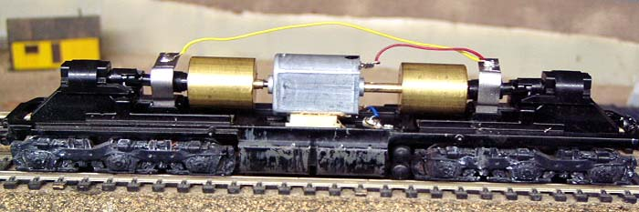
KIT INCLUDES:

1 FLAT CAN MOTOR WITH SHAFT EXTENSIONS, HARDWARE, AND ILLUSTRATED INSTRUCTIONS

MOTOR SPECS:
SIZE 25mm X 20mm X 15mm
SHAFT 10mm X 2mm-4mm x 2mm
VOLTAGE 12VDC
RPM 7800
CURRENT 58ma
STALL CURRENT 800ma

THIS KIT IS ENGINEERED TO UTILIZE THE EXISTING
ATHEARN FLYWHEELS AND DRIVE COMPONENTS
THE PHOTO SHOWS THE MOTOR KIT INSTALLED ON
AN ATHEARN SD9 CHASSIS (NOT INCLUDED WITH KIT)

PLEASE NOTE:
THIS KIT FITS ALL ATHEARN EMD HOOD and CAB UNITS, FM Trainmaster GE HOOD UNITS
BALDWIN and EMD SWITCHERS
Not intended for use in DD35/DD40

