CHINO BACKSHOPS
CAN MOTOR RE-POWER KITS

KIT#15 HO SCALE AHM/ RIVAROSSI 0-8-0
STEAM LOCOMOTIVE

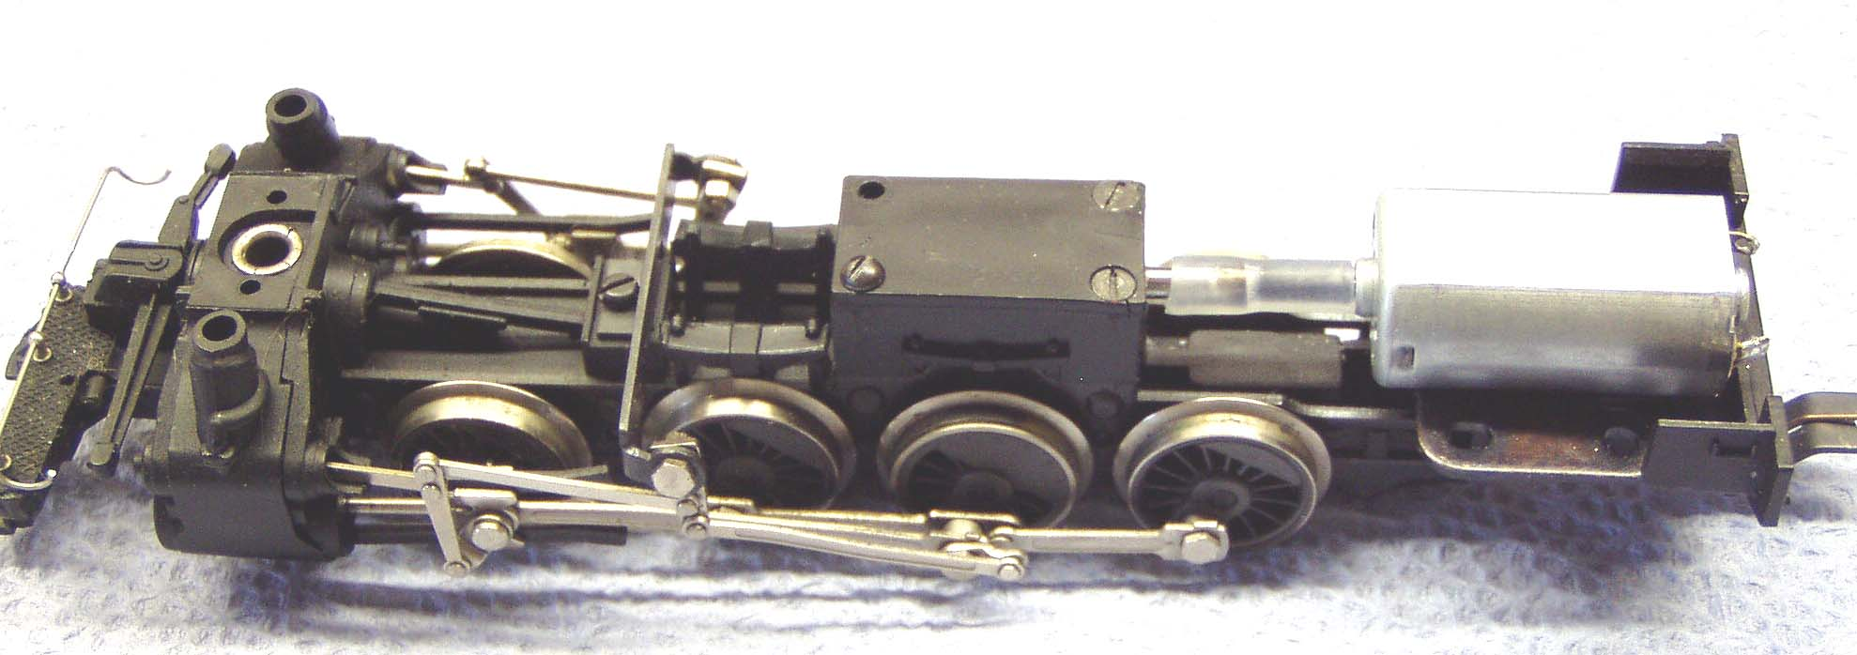

KIT INCLUDES:

1 FLAT CAN MOTOR, FLEXIBLE COUPLING, AND ILLUSTRATED INSTALLATION INSTRUCTIONS

MOTOR SPECS:
12VDC 48ma 5500rpm
1.04” X 0.461” X 0.619” 27mm X 12mm X 16mm
1.5mm shaft, 10mm long

THE PHOTO SHOWS THE MOTOR KIT INSTALLED ON A
HO SCALE RIVAROSSI 0-8-0 CHASSIS (NOT INCLUDED WITH KIT)

PLEASE NOTE: THIS KIT IS INTENDED FOR THE EARLY VERSION 0-8-0 WITH THE SQUARE MOTOR MOUNTED HORIZONTALLY IN THE CAB

